Chapter 19, Solution 22.

To obtain y₁₁ and y₂₁, consider the circuit below.

5 Ω I₂

+ +

I₁ 5Ω 0.5V₂ 2Ω V₂=0
V₁
–
–

The 2-Ω resistor is short-circuited.
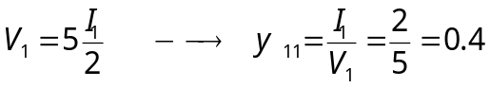
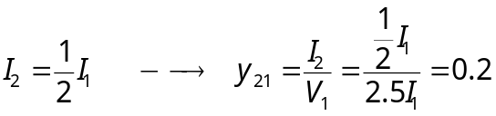

To obtain y₁₂ and y₂₂, consider the circuit below.

I₁ 5 Ω

+ +

5Ω 0.5V₂ 2Ω V₂ I₂
V₁=0
–
–

At the top node, KCL gives
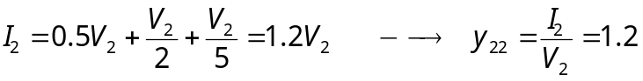
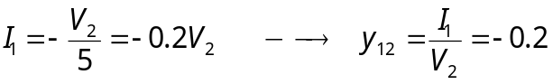

Hence,

